**HEALTHY EATING POLICY**

Through this policy the school aims to help all those in our school community; children, staff and parents in developing positive and responsible attitudes to eating and to appreciate the contribution that good food makes to health.

Nutrition, i.e. what people eat, is known to be one of the key factors influencing their health and well-being. All children bring a packed lunch to school in addition to a snack for the morning break. Food is also a feature of school celebrations. The taught curriculum provides an opportunity to teach about food and healthy lifestyles.

**It is the policy of our school that:**

• Healthy lunches be encouraged and fizzy drinks, sweets, bars, chocolate and crisps

be discouraged.

• A healthy lunchbox includes a piece of food from each of the bottom four shelves

of the Food Pyramid. e.g. ham sandwich, carton of orange juice and

strawberry yogurt.

• Friday is treat day. On this day one piece of food from the top shelf of the

Pyramid may be included.

• Cans and glasses are not permitted for safety and litter reasons. Healthier choices

for drinks include water, milk and unsweetened fruit juice.

• Foods, which have wrappers, are best kept to a minimum. All food wrappings must

be brought home and we encourage the use of lunchboxes and reusable bottles for

drinks.

**To help highlight awareness of healthy school lunches the following will take place**:

• The Healthy School Lunches guidelines (SEHB) will be displayed in every classroom and the

staff room and will be referred to by the teachers.

• A poster of the Food Pyramid will also be displayed in every classroom and the staff room

and will be referred to by the teachers.

• At the beginning of each school term teachers and pupils will discuss healthy eating.

• During the year all classes will receive a minimum of two lessons on healthy eating.

• Parents will be offered the opportunity to attend a healthy eating information evening

facilitated by a dietitian.

• Teachers will provide positive modelling and supportive attitudes to encourage healthy

eating.

• In May, this policy will be reviewed and a Healthy Eating Awareness week will be held.

Adapted from Healthy Eating Guidelines - A Resource Pack for Primary Schools, Health Promotion Service, NWHB, 2002.

**GUIDELINES FOR A HEALTHY LUNCH POLICY**

**Implementation**

• Ensure that the whole staff team is familiar with the policy and is prepared to work within it.

• Ensure that everyone is aware of changes that the policy will make in practice.

• Invite the community dietician to speak at a meeting of parents and staff.

**Monitoring**

• Highlight the positive aspects of individual lunches in the classroom.

• Discuss the contents of school lunch boxes in class.

**Sustaining and strengthening your Policy within the school and home**

• Praise and affirmation.

• Reminders on school letters/ newsletters throughout the year.

• A “fun event” to highlight healthy lunches. This could include a competition, artwork or

display.

• Inform all new staff of the policy.

• Ensure that the guidelines are clearly displayed.

• Display the Food Pyramid poster and any other relevant posters.

• Use national campaigns, for example National Healthy Eating Week, to highlight awareness.

• Link in with local shops to promote healthy lunch choices (i.e. sandwich and fruit for sale at

special low price).

**An information leaflet will be handed out to all parents at the beginning of the school year.**

**Sample Lunch Policy:**

Much of the recent focus on children’s health has been in the areas of nutrition, exercise and rising levels of obesity.  It is therefore timely that the Schools support parents in providing healthy food that will enable their children to participate fully in the school day.  By raising nutrition awareness amongst our children we are providing them with a basis to make informed choices about their health into the future.

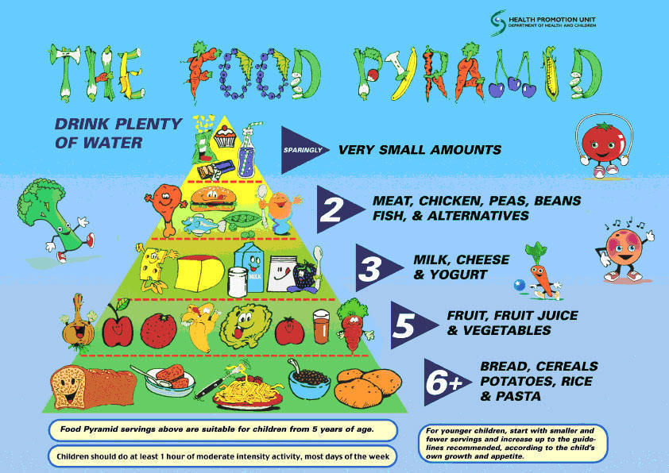

A healthy lunch includes:

      2 servings from the bottom shelf; and

      1 serving from the next three shelves.

Fluid intake is very important and children should be encouraged to take a drink with their meal.  The children will be allowed to drink water during the school day if it is provided in a non-spill bottle.

The children will be allowed to drink water during the school day if it is provided in a non-spill bottle.

|  |  |  |  |  |
| --- | --- | --- | --- | --- |
| **Good Choices** |  | **Only At Meal Times** |  | **Not Tooth Friendly** |
| **Water** |  | **Diluted Sugar Free Squash** |  | **Fruit Drinks** |
| **Milk** |  | **Unsweetened Fruit Juice** |  | **Fizzy Drinks** |

**Lunch Box Ideas**

Keep food manageable e.g. give a peeled orange.

|  |
| --- |
| Pitta Bread with Salmon  Cheese Unsweetened Fruit Juice |

Avoid messy foods e.g. Frubes which spill easily when opened

The aim of Kilconly National School’s Lunch Policy is to promote a culture of healthy eating within the school community.

This aim will be achieved by

*       providing clear guidance in relation to suitable school lunches/snacks;

*       giving parents suggestions and tips on appropriate foods and portion sizes; and

*        incorporating the healthy eating message into the school day through both formal and informal lessons.

The following items should not be included in your child’s lunchbox for the reasons stated:

|  |  |
| --- | --- |
| **Actively discouraged:** | **Because:** |
| Nuts | they represent a choking hazard and a number of pupils are allergic to them |
| Sweets  Chocolate Bars  Crisps & similar snacks  Fizzy Drinks | they are on the top shelf of the pyramid |
| Chewing Gum | it represents a litter problem |

MCj02172020000[1]